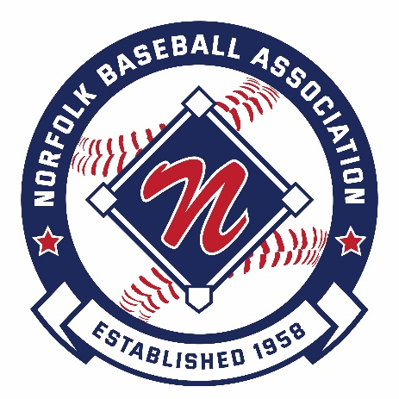

2024
Norfolk Baseball Association Scholarship

The Norfolk Baseball Association is pleased to sponsor a scholarship in the amount of $1,000 for a player who has played in the Norfolk Baseball Association and is furthering his/her education beyond high school.

The mission of the Norfolk Baseball Association is to provide an opportunity for Norfolk children to play and learn the game of baseball, help improve their skills and confidence, promote the principles of good sportsmanship and integrity, self-respect and respect for others, and to do so within a safe, fun, and nurturing environment.

Scholarship Eligibility

In order to be considered for the Norfolk Baseball Association scholarship, candidates must meet the following criteria:

- Currently reside in Norfolk Massachusetts.
- Have played a minimum of four spring baseball seasons in Norfolk Baseball programs.
- Will be graduating from high school in the spring of 2024.
- Will continue their education in the fall of 2024 through enrollment at an accredited college, university, or vocational school.
- Personally available to participate in a presentation ceremony to be held on our opening day to be held April 27th, 2024 of the Norfolk Baseball Association and receive the award in person.
- Accepts that your name or picture may be used on the website and social media to help promote Norfolk Baseball and this scholarship.

To be considered for the Norfolk Baseball Association scholarship, applicants must:

- Complete the attached information form.
- Submit one essay (approximately 300 words) that shares a memory, lesson learned etc., from your experience in Norfolk Baseball that will help prepare you for your future.
- Submit a 2nd short response (100-200 words) that shares your plans for continued involvement in the game of baseball after graduation.
- E-Mail the completed application and essay to commissioner@norfolkbaseball.com. Submissions must be received no later than March 29th 2024.

2024 Norfolk Baseball Scholarship Application (Part 1)

Applicant Information:

Applicant Name: |  | ________________________________________________________
Address: |  | ________________________________________________________
Telephone: |  | ________________________________
Email: |  | ________________________________________________________
Parent/Guardian Name: |  | ________________________________________________________
Address: |  | ________________________________________________________
Telephone: |  | ________________________________
Email: |  | ________________________________________________________
High School: |  | ________________________________________________________
Date of Graduation: |  | ________________________________

Fall 2023 College/University/Vocational School: ________________________________________ Course of Study: ________________________________________________________

Norfolk Baseball Association Experience (complete all 4):

Year: |  |  | ________________________________
League: |  |  | ________________________________
Team Name: |  |  | ________________________________
Manager Name: |  |  | ________________________________________________________
Year: |  |  | ________________________________
League: |  |  | ________________________________
Team Name: |  |  | ________________________________
Manager Name: |  |  | ________________________________________________________
Year: |  |  | ________________________________
League: |  |  | ________________________________
Team Name: |  |  | ________________________________
Manager Name: |  |  | ________________________________________________________
Year: |  |  | ________________________________
League: |  |  | ________________________________
Team Name: |  |  | ________________________________
Manager Name: |  |  | ________________________________________________________

2024 Norfolk Baseball Scholarship Application (Part 2)

Personal References (complete all 3):

Name: | ________________________________________________________
Address: | ________________________________________________________
Telephone: | ________________________________
Email: | ________________________________________________________
Relationship to applicant: | ________________________________________________________
Name: | ________________________________________________________
Address: | ________________________________________________________
Telephone: | ________________________________
Email: | ________________________________________________________
Relationship to applicant: | ________________________________________________________
Name: | ________________________________________________________
Address: | ________________________________________________________
Telephone: | ________________________________
Email: | ________________________________________________________
Relationship to applicant: | ________________________________________________________

2024 Norfolk Baseball Scholarship Application (Part 3)

- Submit an essay (approximately 300 words) that shares a memory, lesson learned etc., from your experience in Norfolk Baseball that will help prepare you for your future.

- Please submit your academic transcript for the last 2 Semesters and a brief detail of your extracurricular activities, groups, and community involvement beyond baseball.

If you prefer to mail the completed application and essay to the Norfolk Baseball Association please use the address below. Submissions must be postmarked no later than Saturday March 26th, 2023. Mail submissions to:

Norfolk Baseball Association
Post Office Box 176
Norfolk, MA 02056

