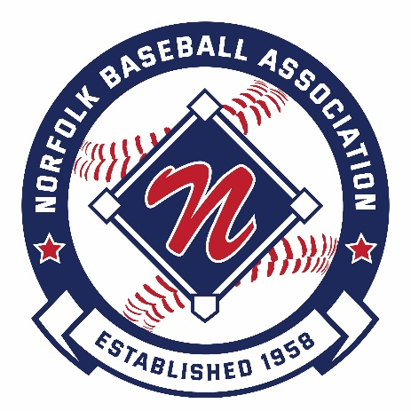

2022
Norfolk Baseball Association Scholarship

The Norfolk Baseball Association is pleased to sponsor two scholarships, in the amount of $1,000 each, for players who have played in the Norfolk Baseball Association and are furthering their education beyond high school.

The mission of the Norfolk Baseball Association is to provide an opportunity for Norfolk children to play and learn the game of baseball, help improve their skills and confidence, promote the principles of good sportsmanship and integrity, self-respect and respect for others, and to do so within a safe, fun, and nurturing environment.

Scholarship Eligibility

In order to be considered for the Norfolk Baseball Association scholarship, candidates must meet the following criteria:

- Currently reside in Norfolk Massachusetts.
- Have played a minimum of four spring baseball seasons in Norfolk Baseball programs.
- Will be graduating from high school in the spring of 2022.
- Will continue their education in the fall of 2022 through enrollment at an accredited college, university, or vocational school.
- Personally available to participate in a presentation ceremony to be held on our opening day to be held April 30th, 2022 of the Norfolk Baseball Association and receive the award in person.

To be considered for the Norfolk Baseball Association scholarship, applicants must:

- Complete the attached information form.
- Submit an essay (approximately 300 words) that shares a memory, lesson learned etc., from your experience in Norfolk Baseball that will help prepare you for your future.
- Mail the completed application and essay to the Norfolk Baseball Association at the address below. Submissions must be postmarked no later than April 14th 2022. Please mail submissions to:

Norfolk Baseball Association
Post Office Box 176
Norfolk, MA 02056

Selection Committee

The Trustees of the Norfolk Public Library review all submissions and recommend the winning entry.

2022 Norfolk Baseball Scholarship Application (Part 1)

Applicant Information:

Applicant Name: |  | ________________________________________________________
Address: |  | ________________________________________________________
Telephone: |  | ________________________________
Email: |  | ________________________________________________________
Parent/Guardian Name: |  | ________________________________________________________
Address: |  | ________________________________________________________
Telephone: |  | ________________________________
Email: |  | ________________________________________________________
High School: |  | ________________________________________________________
Date of Graduation: |  | ________________________________

Fall 2022 College/University/Vocational School: ________________________________________ Course of Study: ________________________________________________________

Norfolk Baseball Association Experience (complete all 4):

Year: |  |  | ________________________________
League: |  |  | ________________________________
Team Name: |  |  | ________________________________
Manager Name: |  |  | ________________________________________________________
Year: |  |  | ________________________________
League: |  |  | ________________________________
Team Name: |  |  | ________________________________
Manager Name: |  |  | ________________________________________________________
Year: |  |  | ________________________________
League: |  |  | ________________________________
Team Name: |  |  | ________________________________
Manager Name: |  |  | ________________________________________________________
Year: |  |  | ________________________________
League: |  |  | ________________________________
Team Name: |  |  | ________________________________
Manager Name: |  |  | ________________________________________________________

2022 Norfolk Baseball Scholarship Application (Part 2)

Personal References (complete all 3):

Name: | ________________________________________________________
Address: | ________________________________________________________
Telephone: | ________________________________
Email: | ________________________________________________________
Relationship to applicant: | ________________________________________________________
Name: | ________________________________________________________
Address: | ________________________________________________________
Telephone: | ________________________________
Email: | ________________________________________________________
Relationship to applicant: | ________________________________________________________
Name: | ________________________________________________________
Address: | ________________________________________________________
Telephone: | ________________________________
Email: | ________________________________________________________
Relationship to applicant: | ________________________________________________________

2022 Norfolk Baseball Scholarship Application (Part 3)

Submit an essay (approximately 300 words) that shares a memory, lesson learned etc., from your experience in Norfolk Baseball that will help prepare you for your future.

Mail the completed application and essay to the Norfolk Baseball Association at the address below. Submissions must be postmarked no later than Saturday April 2, 2016. Mail submissions to:

Norfolk Baseball Association
Post Office Box 176
Norfolk, MA 02056

